Lab Exercise 9- Managing Namespaces in Kubernetes

# Step 1: Understand Namespaces

Namespaces provide a mechanism for scoping resources in a cluster. Namespaces can be used to:

* Create environments for different applications or teams.
* Apply policies like resource quotas or network policies on a per-namespace basis.
* Separate operational environments (like development and production).

# Step 2: List Existing Namespaces

To list all the namespaces in your Kubernetes cluster:

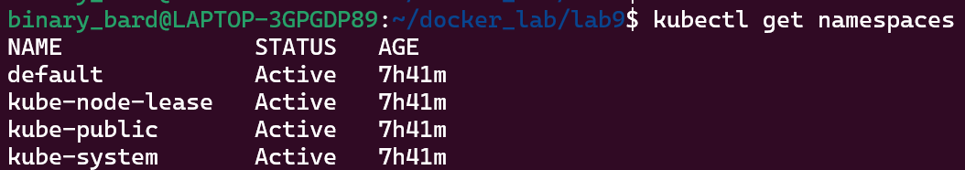

kubectl get namespaces

You will typically see default namespaces like default, kube-system, and kube-public.

# Step 3: Create a Namespace

You can create a namespace using a YAML file or directly with the kubectl command.

# Using YAML File

Create a file named ***my-namespace.yaml*** with the following content:

apiVersion: v1 kind: Namespace metadata:

name: my-namespace

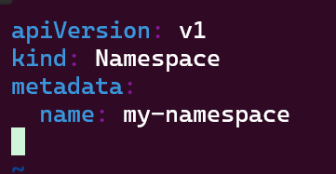

Apply this YAML to create the namespace:



kubectl apply -f my-namespace.yaml

Verify that the namespace is created:

kubectl get namespaces

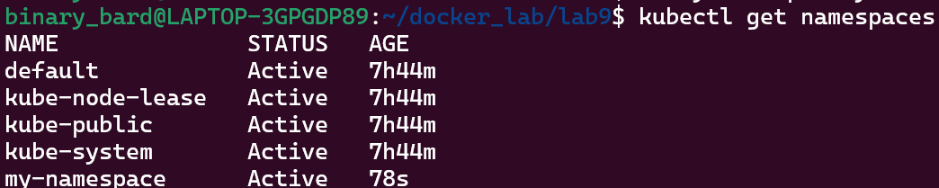

You should see my-namespace listed in the output.

# Step 4: Deploy Resources in a Namespace

Create resources such as Pods, Services, or Deployments within the new namespace. Deploy a Pod in the Namespace

Create a YAML file named ***nginx-pod.yaml*** with the following content:

apiVersion: v1 kind: Pod metadata:

name: nginx-pod

namespace: my-namespace # Specify the namespace for the Pod. spec:

containers:

- name: nginx image: nginx:latest ports:

- containerPort: 80

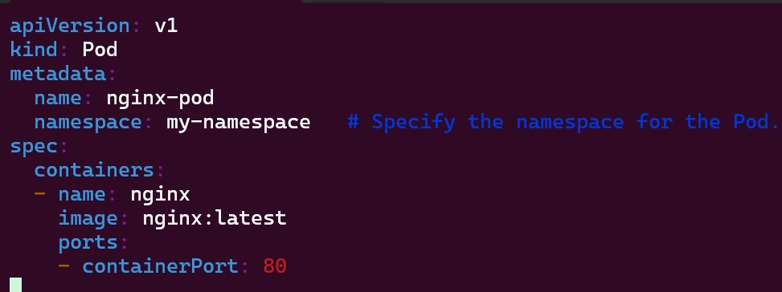

Apply this YAML to create the Pod:



kubectl apply -f nginx-pod.yaml

Check the status of the Pod within the namespace:



kubectl get pods -n my-namespace

To describe the Pod and see detailed information:

kubectl describe pod nginx-pod -n my-namespace

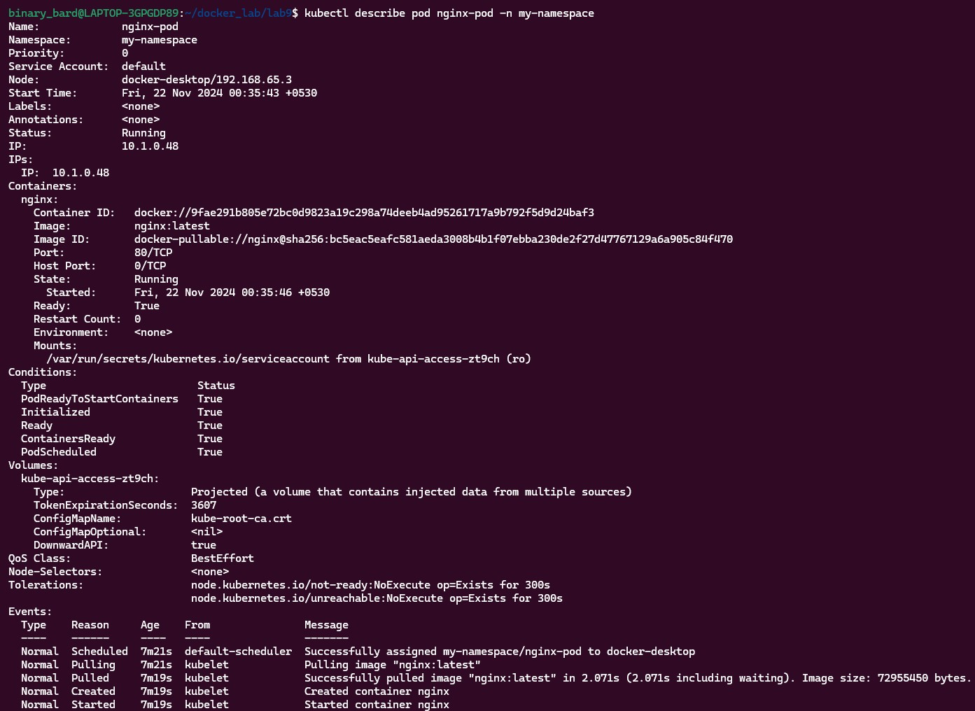

Create a Service in the Namespace

Create a YAML file named nginx-service.yaml with the following content:

apiVersion: v1 kind: Service metadata:

name: nginx-service

namespace: my-namespace # Specify the namespace for the Service. spec:

selector:

app: nginx-pod ports:

- protocol: TCP port: 80

targetPort: 80 type: ClusterIP

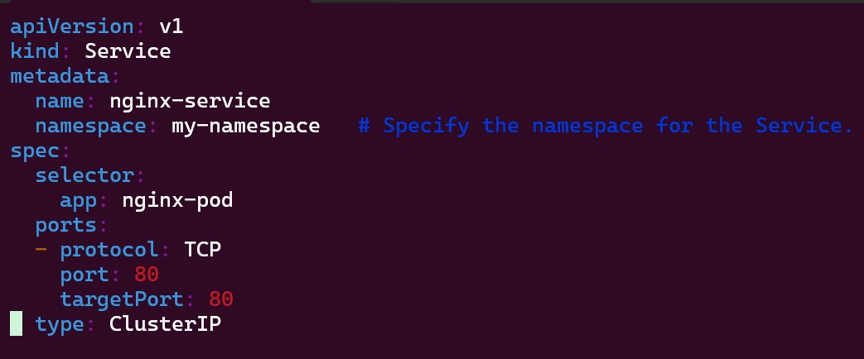

Apply this YAML to create the Service:



kubectl apply -f nginx-service.yaml

Check the status of the Service within the namespace:



kubectl get services -n my-namespace

To describe the Service and see detailed information:

kubectl describe service nginx-service -n my-namespace

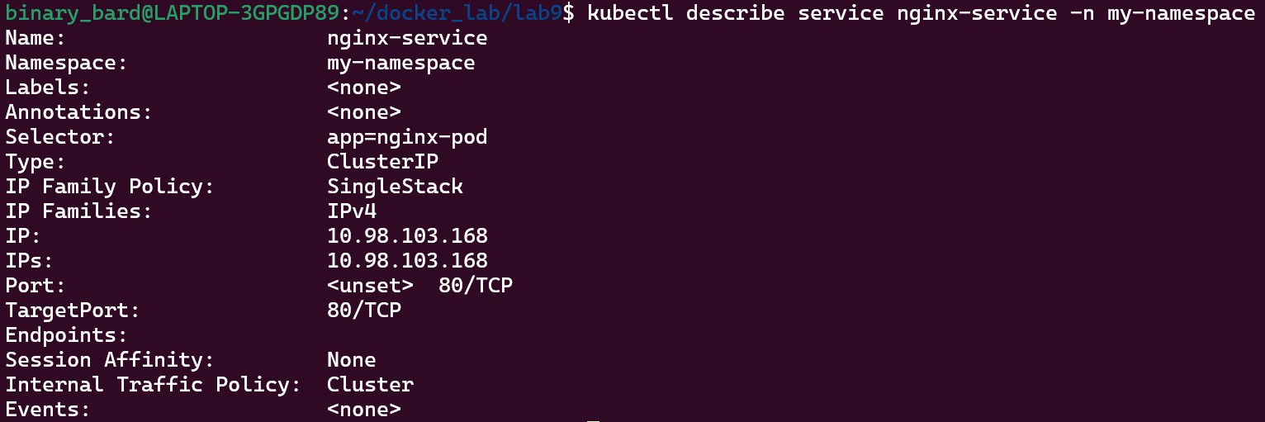

# Step 5: Switching Context Between Namespaces

When working with multiple namespaces, you can specify the namespace in kubectl commands or switch the default context.

# Specify Namespace in Commands

You can specify the namespace directly in kubectl commands using the -n or --namespace flag:



kubectl get pods -n my-namespace

# Set Default Namespace for kubectl Commands

To avoid specifying the namespace every time, you can set the default namespace for the current context:



kubectl config set-context --current --namespace=my-namespace

Verify the current context’s namespace:

kubectl config view --minify | grep namespace:



# Step 6: Clean Up Resources

To delete the resources and the namespace you created:

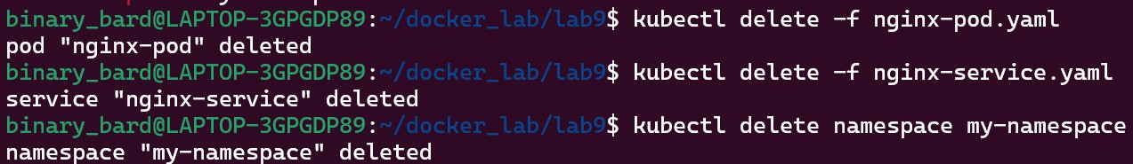

kubectl delete -f nginx-pod.yaml kubectl delete -f nginx-service.yaml

kubectl delete namespace my-namespace

Ensure that the namespace and all its resources are deleted:

kubectl get namespaces

